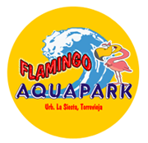
The AquaPark Flamingo Torrevieja is open from:
3rd June 2016 (03/06/2016) until the 8th September 2016 (08/09/2016)

The opening times are: 11.00am – 6.00pm

Ticket Prices
Type of Ticket | Ticket Office (from)
Under 4 years old | FREE
Ages  4 - 12 | €7.00
Adults  12+ | €9.00

